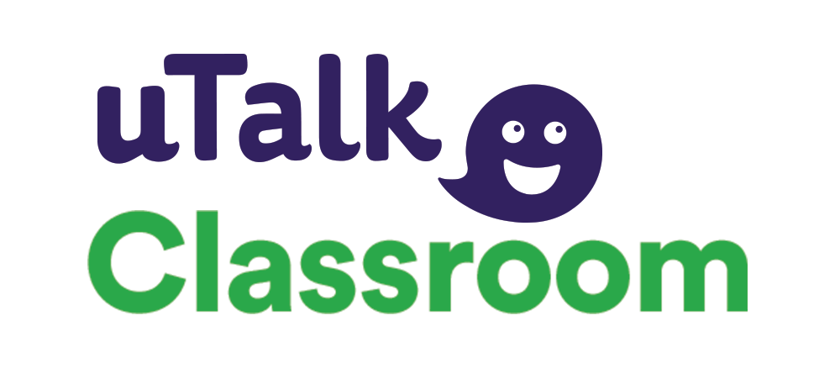

Why uTalk Classroom?

The uTalk app ticks the right boxes for schools. Here’s why!

The app:
- Offers a choice of over 140 languages, to be learnt from over 100 source languages
- Features 60 topics per language
- Can be used on any device – it is multi-platform
- Enables you to work online or offline
- Enhances speaking and listening skills
- Gives ideal preparation for more open-ended speaking activities
- Features English for EAL as an extra (free) option
- Is designed to be ideal for IWB, personal use, homework, clubs, extension or support activities

It gives students:
- Achievable goals
- The ability to work independently at their own pace and in their own time
- The ability to practice at word, phrase and sentence level
- Memory-boosting strategies: every word is accompanied by a picture
- Progressively challenging games with points for correct answers
- Constant encouragement

It gives teachers:
- A choice of 140+ languages
- Authentic native speakers voicing every word
- A way of monitoring each student’s progress
- A teacher dashboard to track engagement, progress and achievement

Interested? Want to know more? Call us on 07749 288578 or email susannah@utalk.com

